Jocelyn Tan Lian Sze (33357307)

FIT1050 Assignment 3 Report

Website link: <https://jocelyn828.github.io/FIT1050-A3.github.io/>

**Introduction**

This report outlines the redesign of a website for a local pizza business. The website provides essential business information such as the menu, location, operating hours, and more. It aims to offer a convenient platform for customers.

Puckapunyal Pizza & Pasta is a small local business that serves delicious pizzas and pastas, made with homemade bases and sauces in store. The target audience for this website includes:

* Current customers: Customers that are familiar with the restaurant use the website to check out menu and place order.
* Potential customers: Customers that are looking for new dining options in the community through searching engines.

For example, the current customers can be individuals who are pizza lovers, love to try out new and unique dishes. They could use the website to view the specials menu. Also, they may be individuals who need to keep their budget, they can visit the website and view the latest promotions of the restaurant.

Potential customers include individuals with dietary preferences such as vegetarian or gluten-free. They can use the website and check out the detailed ingredient information to ensure the restaurant’s offerings meet their dietary needs.

**Site content and major features**

The homepage has six sections: ‘Navigation Menu’, ‘Hero Section’, ‘Promotion Section’, ‘Special Menu Section’, ‘Feedback Section’, and the footer.

Navigation Menu:

The navigation menu includes essential elements such as the menu link and the 'Contact Us' button. It is fixed at the top of the page, to ensure that users can easily access these key features without scrolling. This approach can enhance efficiency for users who want to change to other section quickly.

Hero Section:

Since hero section is the first element users see when they enter the website, having restaurant name in the center, with a pizza image as the background can let users instantly know what the business is about. This clarity and simplicity can build brand recognition (name of the restaurant), and enhance the user experience.

Promotion Section:

The promotion section highlights the latest promotions, capturing users' attention and informing them about the current deals. This common business strategy can stimulate interest in the menu.

Special Menu Section:

Since there are wide range of dishes, it is not feasible to list all items. Instead, the Special Menu Section displays selected dishes. Accompanying with the food images, it provides a clear and attractive visual representation of the food.

Feedback Section:

The feedback section is used to display customer reviews, which can add credibility of the website. The content that regularly updates can improve the SEO performance, and thus increase visibility in local search results. This section can also extend the duration of user visits, increase the likelihood of visitors become customers.

Footer:

The footer includes standard elements such as contact information, location, and additional navigation options, ensuring comprehensive accessibility throughout the website.

**Visual Design Style**

I have used red colour as the primary colour of the website. This decision is made to maintain consistency with the style of the original website. Also, red is widely used in the food industry, such as Pizza Hut, KFC, and etc.

For the typography, two font families are used for the website, ‘Montserrat’ for headers and ‘Work Sans’ for body text. This maintains the visual consistency and clarity of the website. By using a bold weight for ‘Montserrat’ in headers and a light weight for ‘Work Sans’ in body text, it help the users to differentiate the importance of the word immediately, at the meantime, it is visually appealing and perfect for the modern website. In case the custom fonts are not available, ‘sans-serif’ is the backup font I used to maintain readability.

**Image Optimisation**

For the website, I have used WebP, SVG, and JPG format images for different purposes.

I used WebP for the star rating image in review section, and the logo that is used as the favicon as well as in the top left of navigation menu. Both images have transparent background, which is not supported by JPG format. The logo design is also complex, with multiple colours and details, they are best preserved in the lossless WebP format. Other transparency supported formats like SVG may lose quality or lack of details, and PNG files tend to have large size, which can affect the page loading speed. Therefore, I have used WebP to maintain the quality while having small image size.

SVG format is used for the website text logo in the hero section. This is because SVG supports transparency and the website logo has transparent background. SVG typically has small file size, and it is suitable for logo that has simple design. Its scalability is great to display the logo across different screen sizes without losing the quality, making it the optimal format for the image.

JPG is used for all food images across the website. With many food images displaying in the website, the small file size of JPG is crucial for improving the website performance. Although JPG is lossy, the compression is hard to detect by the human eyes. It is widely used across all browsers, its faster loading times contribute to a smooth user experience and improved the SEO ranking.

**Accessibility**

Following Perceivable principle guidelines, all informative images have been implemented with alternative texts. This is beneficial for users with low vision or users who have poor network connection and image could not be downloaded, to understand what the image is. Besides, the background colour and foreground colour are high contrast to ensure the readability of the content. All button and links are fully accessible using only keyboards, following the Operable principle guidelines. This ensures users who rely on keyboard can interact with the website smoothly and have great users experience.

**JavaScript Interaction**

To enhance user interaction on the website, I have implemented button for each menu item that triggers modals, allows users to view menu item details. Since information such as ingredients and dietary preferences can contain lots of texts, directly display them may not be visual appealing as there are too much words. Using modal, it allows users to access detailed information without leaving the main page. This enhances user experience by allowing users to view additional content while staying engaged with the main content.

This approach is referenced from the Pizza Hut website, it can keep users engaged with the content, which is important for businesses like restaurants.

Furthermore, using modals can minimize page loads and boost the speed of the website. To maintain consistent functionality regardless of the method of accessing the website, I have adjusted the JavaScript code that other content cannot be accessed until users close the modal window. Users can close the modal either by pressing the escape key or clicking the close button, ensuring accessibility for keyboard users.

font

<https://artisanthemes.io/best-google-fonts-combinations-modern-agency-website/>

Navigation

<https://codestitch.app/app/dashboard/stitches/757?nav=Top%20Dropdown>

promotion

<https://codestitch.app/app/dashboard/stitches/1567>

* Three pizzas
* <https://www.pexels.com/photo/an-assortment-of-pizzas-on-wooden-cutting-boards-12046657/>
* Pastas
* <https://www.pexels.com/search/pasta%20promotion/?orientation=landscape>

food menu

<https://codestitch.app/app/dashboard/stitches/1001>

* special01
* <https://www.pexels.com/photo/italian-style-pizza-13814644/>
* sepcial02
* <https://www.pexels.com/photo/pizza-on-a-wooden-table-16890470/>
* special03
* <https://www.pexels.com/video/wood-fired-sourdough-pizza-margherita-time-16013244/>
* special04
* <https://www.pexels.com/photo/pizza-with-mozzarella-shaped-as-ghosts-for-halloween-18912713/>
* sepcial05
* <https://www.pexels.com/photo/sourdough-pizza-baked-low-and-slow-in-a-pizza-oven-20882533/>
* special06
* <https://www.pexels.com/photo/cooked-penne-pasta-on-black-plate-11419099/>

<https://codestitch.app/app/dashboard/stitches/1446>

centered

<https://codestitch.app/app/dashboard/stitches/998>

* background

<https://www.pexels.com/photo/close-up-photo-of-person-holding-pizza-1653877/>

review

<https://codestitch.app/app/dashboard/stitches/62>

rating

<https://pixabay.com/vectors/rating-review-five-star-rating-6930474/>

footer + contact

<https://codestitch.app/app/dashboard/stitches/1763>

<https://looka.com/editor/184308742>

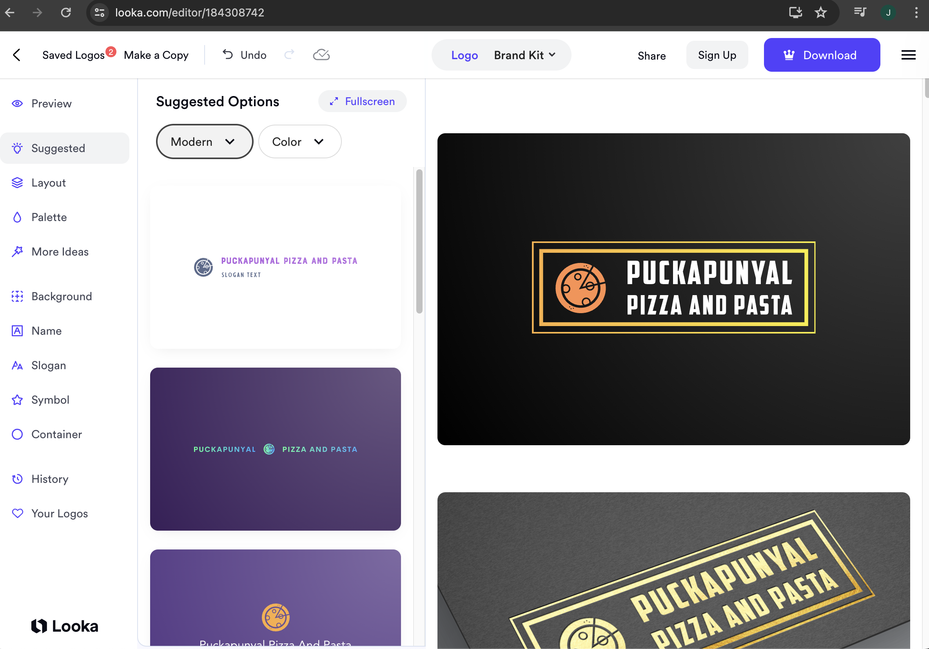

Trap focus in modal

<https://hidde.blog/using-javascript-to-trap-focus-in-an-element/#:~:text=Trapping%20focus%20is%20a%20behaviour,to%20interact%20with%20our%20component>.

YouTube tutorial create modal

<https://www.youtube.com/watch?v=MBaw_6cPmAw&t=111s>

scroll to

<https://stackoverflow.com/questions/70552182/scroll-to-section-in-html-css>

overlay

<https://stackoverflow.com/questions/74464099/js-overlay-background>

no scroll when overlay

<https://stackoverflow.com/questions/49101060/prevent-body-scrolling-when-overlay-on-with-body-overflow-scroll-by-default>

work sans fonts

<https://fonts.google.com/specimen/Work+Sans?query=work+sans>

Montserrat fonts

<https://fonts.google.com/specimen/Montserrat?query=Montserrat>

svg benefits

<https://cloudinary.com/guides/image-formats/svg-format-features-common-uses-and-pros-cons-you-should-know-2#scalability>

Ricard, J. (2022, March 1). Guide 101: Color Psychology In Website Design. Reference from:

Klizo Solutions. <https://klizos.com/guide-101-color-psychology-in-website-design/>

Customer review published on website

<https://skeepers.io/en/blog/integrate-customer-reviews-website/>

what Is modal

<https://www.wisegrowthmarketing.com/what-is-a-modal/>